**No. 78 - “ Gazelle ” - Schooner**

**Details of Ship:-**

Built: May 1839

Type: Schooner

Tonnage: 110 tons *(Lloyd’s Register – 120 Tons)*

Dimensions: Length: 76.6, Beam: 17.3, Depth: 11.0

Work carried out: 1843, Yellow metalled.

1848, Yellow metalled.

1852, Yellow metalled.

Builder: **William Mumford (Mu05)** of Scilly. 10 yrs. A1.

Owners: 1839, Lakey & Co.

1840 – 1848, **Banfield (B057)**

1844 – 1852, **Banfield (B057)** & W. Lakey.

1852, **A. Banfield (Mu08)** & W. J. Lakey

1851 - 1852, W. Lakey

1855, Lakey & Co

Captains: 1839 – 1849, T. Lakey

1844, J. Anderson

1850 – 1855, William James Lakey [aged 26]in 1851]

1854, W. Davies

1845 – 1855, Lakey *(RWB Note: T. Lakey was drowned when the vessel was lost in January 1854 )*

Registered: March 1839 – 1852, 1854 - 1855, Scilly.

1853, Vessel not listed on Lloyd’s register.

Port of Survey: 1840 - 1841, Scilly

1842 - 1848, Liverpool

1849 - 1852, London

1853, Vessel not listed on Lloyd’s register.

1854 - 1855, Scilly

Trade: **Foreign.** (London – St. Michael). Genoa 1843, Gibraltar, Melbourne (Australia), Newfoundland, St Michael's 1851. Liverpool, Leghorn, Bristol, Scilly, London, Harbour Grace (Newfoundland), Dublin, Smyrna, Falmouth, Naples, Plymouth, Vostigga, Genoa, Malta, Corfu, Patras, Ionian Islands, Gallipoli, Newcastle, Barcelona, Cork, Trieste, Zante, Cephalonia, Newport, Palermo, Mauritius,

Cargo: 1854, Sugar, Coffee, Cigars

Signal:

Official No.:

Demise: 21.12.1854, Lloyds Reg. details: Wrecked Bahamas 1855, Lloyds Reg. 1855 marked “Lost”.

The *“Gazelle”*, of Scilly, from St. Jago de Cuba to St. Johns, Newfoundland, was totally lost at Inaqua, on the 30th. January – master drowned, cargo (sugar, coffee, and cigars) lost, and small part of material saved.

***2.6.1852, Source: Tide Surveyor’s Certificate of Admeasurement – “Gazelle”.:-***

**Surveyor’s Certificate of Admeasurement.**

For Vessels under the Act of 8 & 9 Vict., 89, and 12 & 13 Vict., c. 29.

**Port of** *Scilly* **No.** *6.*

**This** is to Certify that the Ship or Vessel called the

*Gazelle* of *Scilly*

Burthen *one hundred & nine 6/10th*

Tons, whereof *William James Lakey* is at present Master,

is *British* built, has *one and a break* deck and *two* Masts;

that her length from the inner part of the main Stem to the fore part of the

Stern Post aloft is *Seventy six* feet *six* tenths,

her breadth in Midships is *Seventeen*

feet three tenths; her depth in hold at Midships is *Eleven*

feet *~~~~~~~~~~~* tenths; that she is *Schooner* rigged with

a *standing* Bowsprit, is *square* sterned *Carvel*

built, has *no* Galleries, *and a Gazelle* Head, and

that the frame-work and  *planking* is *wood*

and that she is a Sailing Vessel, and appears to be the same Vessel as

described in the *last Certificate of Registry, granted at this Port*

dated *26th July 1844 No. 6*

*now delivered up and cancelled in consequence of change of Property*

Given under my Hand at the Custom-House, this *2nd.*

day of *July* in the year *1852*

*Wm. Nance Actg. Tideservr.*  [signed]

I do hereby on the Part of the Owners of the *Gazelle*

being thereto duly authorized by *their*  consent, and agree to the several

particulars set forth in the above description and admeasurement.

*William James Lakey* [signed]

United Kingdom. – No. 249 – Tide Surveyor’s Certificate of Admeasurement (New Act.)

5 Rms. Dec., 1849

***2.7.1852, Source: Hand written Bond given by Owners – “Gazelle”.:-***

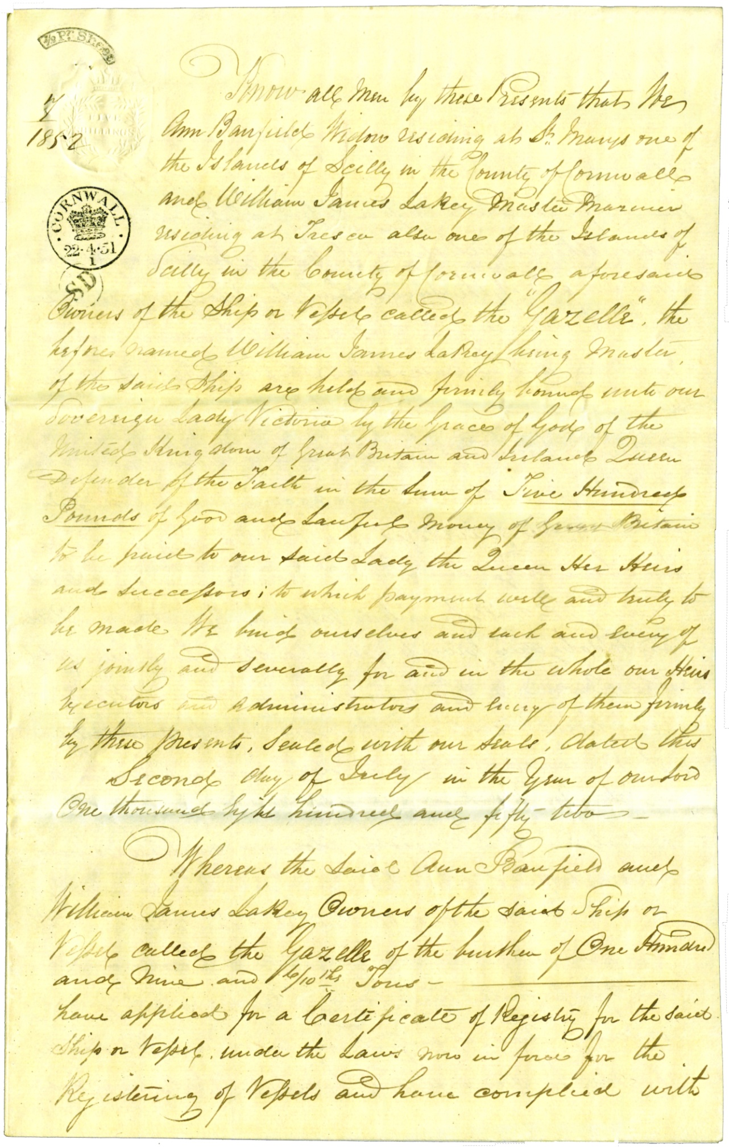

**There were two other pages of hand written text in the middle of the paperwork, with the last page being as below.**

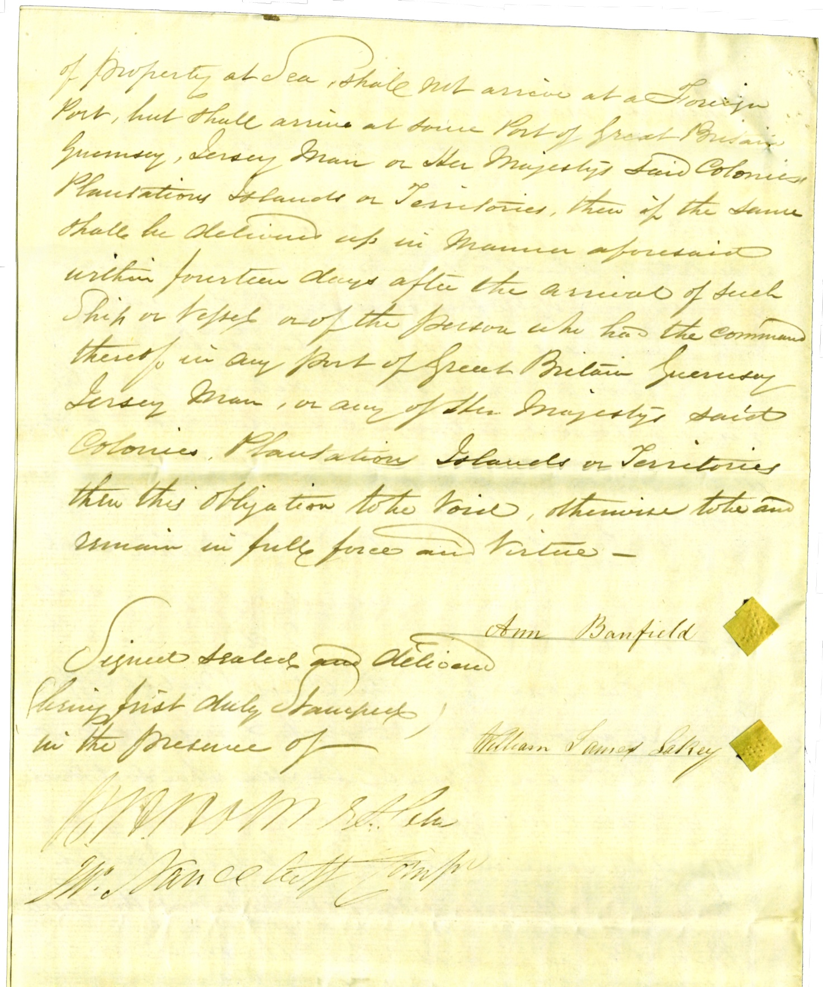

***2.7.1852, Source: Registry Declaration – “Gazelle”.:-***

*We,* ***Ann Banfield (Mu08)*** *of St. Mary’s, Widow, & William James Lakey, of Tresco, both Islands*

*Of Scilly in the County of Cornwall, Master Mariner*

**No. 2.**

do truly declare that the Ship or Vessel *“Gazelle”*

of *Scilly* whereof *William James Lakey*

is at present Master, being of the burthen of *one hundred and nine & 4/10ths.*

Tons

Is *British* built, has *one & a break* Decks and *two*

Masts; that her length from the inner part of the Main Stem to the fore part of the Stern Post aloft is

*Seventy six* feet *Six* tenths, her breadth in Midships is *Seventeen*

feet *three* tenths, her depth in hold at Midships is *Eleven*

feet tenths that she is *Schooner* rigged, with a *Standing*

Bowsprit; is *square* sterned *Carvel* built, has *no* Galleries, and

*A Gazelle* Head; that the Framework and *planking* is *wood* and

That she is a Sailing Vessel and was *built at St. Marys Scilly in the*

*Year one thousand eight hundred and thirty nine, as appears by the last Certificate*

*Of Registry, granted at this Port on the 2nd. July 1844, Gr v R, now delivered up and*

*Cancelled on consequence of a change of Property*

and that *the* the said Ann Banfield and William James Lakey are

sole Owners of the said Vessel, and that no other Person or Persons whatever hath or have any Right, Title, Interest, Share, or Property therein, or thereto; and that *the* the said ***Ann Banfield (Mu08)*** *and William*

*James Lakey are*

truly and bone fide *the*  Subjects of Great Britain, and that *the* the said

***Ann Banfield (Mu08)*** *and William James Lakey*

have not taken the Oath of Allegiance to any Foreign State whatever,

And that no Foreigner, directly or indirectly, hath any Share or Part Interest in the said Ship or Vessel.

***Ann Banfield (Mu08)*** [signed]

Signed and Declared before Us at the Custom House,

in the Port of *Scilly William James Lakey* [signed]

this *2nd.* day of *July 1852*

No. 261. United Kingdom, (Registry Declaration) No. 2. 22 20

2 Reams, -- Dec. 1849

*W H Holmes Coll.*

*Wm. Nance Actg. Compt*

***1851, Crew List:-***

**Basset** Joseph

Current Ship: GAZELLE of Scilly Trade: Foreign Age: 30

Born: Bermuda Ticket No: 482405 Seaman

Date Joined: 27 Feb 1851 Place Joined: Liverpool

Date Left: 11 Jun 1851 Place Left: Bristol Why Left: Discharged

Previous Ship: HUSKISSON of Liverpool Comments: BT 98/: 2702

**Brown** James

Current Ship: GAZELLE of Scilly Trade: Foreign Age: 40

Born: Plymouth Ticket No: Nil Seaman

Date Joined: 04 Aug 1851 Place Joined: Harbour Grace NFD

Date Left: 08 Oct 1851 Place Left: Leghorn Why Left: Discharged

Previous Ship: MYRTLE of Newfoundland Comments: BT 98/: 2702

**Chinn** Thomas

Current Ship: GAZELLE of Scilly Trade: Foreign Age: 20

Born: Hillack Ticket No: 329824 Seaman

Date Joined: 19 Apr 1850 Place Joined: London

Date Left: 13 Jan 1851 Place Left: Liverpool Why Left: Discharged

Previous Ship: BETSY Comments: aka Chum BT 98/: 2702

**Davis** William

Current Ship: GAZELLE of Scilly Trade: Foreign Age: 28

Born: Plymouth Ticket No: 297815 Seaman

Date Joined: 10 Oct 1851 Place Joined: Leghorn

Date Left: 20 Dec 1851 Place Left: Dublin Why Left: Discharged

Previous Ship: CLYDESDALE of Plymouth Comments: BT 98/: 2702

**Gilbert** Edwin G

Current Ship: GAZELLE of Scilly Trade: Foreign Age: 25

Born: Bristol Ticket No: 459308 Seaman

Date Joined: 19 Apr 1850 Place Joined: London

Date Left: 13 Jan 1851 Place Left: Liverpool Why Left: Discharged

Previous Ship: PRIMA DONNA Comments: BT 98/: 2702

**Jenkin** Joseph

Current Ship: GAZELLE of Scilly Trade: Foreign Age: 16

Born: Scilly Ticket No: 266064 Apprentice/Seaman

Date Joined: 30 Apr 1847 Place Joined: Indentured at Scilly

Date Left: 24 Dec 1851 Place Left: Dublin Why Left: Discharged

Previous Ship: GAZELLE of Scilly Comments: aka Jenkins BT 98/: 2702

**Jenkin** Walter

Current Ship: GAZELLE of Scilly Trade: Foreign Age: 15

Born: Scilly Ticket No: 419528 Apprentice

Date Joined: 27 Apr 1850 Place Joined: Indentured at Scilly

Date Left: Remains Place Left: Why Left:

Previous Ship: GAZELLE of Scilly Comments: aka Jenkins BT 98/: 2702

**Jenkins** Stephen

Current Ship: GAZELLE of Scilly Trade: Foreign Age: 50

Born: Scilly Ticket No: 247190 Seaman

Date Joined: 01 Jul 1851 Place Joined: Scilly

Date Left: 24 Dec 1851 Place Left: Dublin Why Left: Discharged

Previous Ship: PETEREL of Scilly Comments: BT 98/: 2702

**Lakey** William James

Current Ship: GAZELLE of Scilly Trade: Foreign Age: 26

Born: Scilly Ticket No: 43450 Master

Date Joined: 19 Apr 1850 Place Joined: London

Date Left: Remains Place Left: Why Left:

Previous Ship: GAZELLE of Scilly Comments: BT 98/: 2702

**McGrath** Andrew

Current Ship: GAZELLE of Scilly Trade: Foreign Age: 23

Born: St Johns NFD Ticket No: Nil Seaman

Date Joined: 08 Oct 1851 Place Joined: Leghorn

Date Left: 20 Dec 1851 Place Left: Dublin Why Left: Discharged

Previous Ship: CLUTREE of St Johns Comments: BT 98/: 2702

**Mcleod** Angus

Current Ship: GAZELLE of Scilly Trade: Foreign Age: 20

Born: Portree Ticket No: 497840 Cook & Ord Seaman

Date Joined: 27 Feb 1851 Place Joined: Liverpool

Date Left: 24 Apr 1851 Place Left: Smyrna Why Left: Deserted

Previous Ship: DARLING of Inverness Comments: BT 98/: 2702

**Rogers** William

Current Ship: GAZELLE of Scilly Trade: Foreign Age: 22

Born: Scilly Ticket No: 290825 Seaman

Date Joined: 04 Mar 1851 Place Joined: Liverpool

Date Left: 11 Jun 1851 Place Left: Bristol Why Left: Discharged

Previous Ship: ARAB Comments: BT 98/: 2702

**Rogers** William C

Current Ship: GAZELLE of Scilly Trade: Foreign Age: 22

Born: Scilly Ticket No: 419560 Seaman

Date Joined: 01 Jul 1851 Place Joined: Scilly

Date Left: 04 Aug 1851 Place Left: Harbour Grace NFD Why Left: Deserted

Previous Ship: GAZELLE of Scilly Comments: BT 98/: 2702

**Rowe** William

Current Ship: GAZELLE of Scilly Trade: Foreign Age: 17

Born: Penzance Ticket No: 462241 Cook & Seaman

Date Joined: 19 Apr 1850 Place Joined: London

Date Left: 13 Jan 1851 Place Left: Liverpool Why Left: Discharged

Previous Ship: VICTORIA Comments: BT 98/: 2702

**Sherris** George

Current Ship: GAZELLE of Scilly Trade: Foreign Age: 22

Born: Scilly Ticket No: 350015 Mate

Date Joined: 27 Apr 1850 Place Joined: Scilly

Date Left: 24 Dec 1851 Place Left: Dublin Why Left: Discharged

Previous Ship: MINCARLO Comments: aka Sherrit MT 66891 BT 98/: 2702

**Smith** William

Current Ship: GAZELLE of Scilly Trade: Foreign Age: 19

Born: Petersborough Ticket No: 531234 Ord Seaman

Date Joined: 01 Jul 1851 Place Joined: Scilly

Date Left: 04 Aug 1851 Place Left: Harbour Grace NFD Why Left: Deserted

Previous Ship: GAZELLE of Scilly Comments: BT 98/: 2702

**Zerri** Calledon

Current Ship: GAZELLE of Scilly Trade: Foreign Age: 30

Born: Trieste Ticket No: Foreigner Seaman

Date Joined: 27 Feb 1851 Place Joined: Liverpool

Date Left: Did not sail Place Left: Why Left:

Previous Ship: HANNAH of Hull Comments: BT 98/: 2702

**Details of Voyages:-**

***19.8.1839, Source: West Briton newspaper:-***

A schooner named *“Gazelle”*, 109 tons, was launched at St. Mary’s from **Mr Mumford’s (Mu05)** yard, and a number of gentlemen afterwards met at **Mr. Mumford’s (Mu05)** house to congratulate him on the success of his labours.

***8.1.1840, Source: The Morning Post.:-***

SHIP NEWS.

FALMOUTH. Jan 5. – Sailed, *“Gazelle”*, Lakey, for St. Michael’s.

***18.2.1841, Source: The Morning Post.:-***

SHIP NEWS.

LIVERPOOL, Feb. 17.

CLEARED OUTWARDS. – The *“Gazelle”*, Lakey, for Naples.

***3.3.1842, Source: Caledonian Mercury.:-***

SHIPPING INTELLIGENCE.

*“Gazelle”*, Lakey, at Plymouth 24th ult. from Leghorn.

***31.3.1843, Source: Royal Cornwall Gazette, newspaper.:-***

**SHIP NEWS.**

SCILLY. – Arrived, *“Gazelle”*, Lukey (sic), from Vostigga.

***29.7.1844, Source: Caledonian Mercury.:-***

SHIPPING INTELLIGENCE.

*“Gazelle”*, Lakey, passed Gibraltar 11th. inst. From Gallipoli for Scilly.

***27.9.1844, Source: Royal Cornwall Gazette.:-***

SHIP NEWS.

SCILLY. – Arrived, *“Gazelle”*, Lakey, from London.

Sailed, *“Gazelle”*, Lakey, for St. John Newfoundland.

***11.7.1845, Source: The Newcastle Courant.:-***

MARINE INTELLIGENCE.

ARRIVED AT FOREIGN PORTS.

Barcelona, June 24. – The *“Gazelle”*, Lakey, from Newcastle.

***17.7.1846, Source: Liverpool Mercury.:-***

LATEST SHIPPING INTELLIGENCE.

THURSDAY JULY 16. – Wind N.W.

SAILED, The *“Gazelle”*, Lakey, Newfoundland.

***26.7.1847, Source: The Morning Post, newspaper.:-***

**SHIP NEWS**

**VESSELS SPOKEN WITH.**

*“Gazelle”*, of Scilly, 12th. inst., off Lisbon; by the *“Saucy Jack”*, arrived at Falmouth.

***8.2.1848, Source: Liverpool Mercury.:-***

SHIP NEWS.

*“Gazelle”*, Lakey, hence at Scilly, and sailed 1st. Feb. for the Ionian Islands.

***20.7.1849, Source: Royal Cornwall Gazette.:-***

SHIP NEWS.

SCILLY. – Arrived, *”Gazelle”,* Lakey, from Gallipoli.

Sailed, *“Gazelle”,* Lakey, for Bristol.

***14.1.1851, Source: Liverpool Mercury.:-***

SHIP NEWS.

*“Gazelle”*, Lakey, from Palermo, at Scilly, with loss of sails, spars, &c., in a gale on the 1st. inst., in lat. 33, lon. 9.

***14.3.1851, Source: Royal Cornwall Gazette.:-***

SHIP NEWS.

SCILLY. – Arrived, *“Gazelle”*, Lakey, from Liverpool.

Sailed, *“Gazelle”*, Lakey, for Smyrna, put back 9th., with loss of jib-boom.

***26.1.1853, Source: The Morning Post, newspaper.:-***

FALMOUTH, 22 Jan., -- Arrived – *“Arcturus”*, from Rouen for Glasgow, with bowsprit, &c., carried away, having been in contact with the *“Gazelle”*, of Scilly, which put in here 20th Jan.

***28.1.1853, Source: The Hull Packet and East Riding Times, newspaper.:-***

**SHIPPING INTELLEGENCE**

ST. MAWES, January 22. – The schooner *“Arturus”*, Lewis, from Rouen for Glasgow, whilst reaching to the westward, four miles outside of Falmouth Harbour, at 7 p.m., 21st. inst., was in contact with the schooner *“Gazelle”*, of Scilly, and carried away bowsprit, jibboom, and cutwater, and other damages. The *“Arturus”* was on starboard tack, and the *“Gazelle”* on the port tack, wind about N.W. by N., blowing strong, and a clear moonlight night.

*(RWB Note: “Gazelle” should have given way to “Arturus”, as she was on Port Tack.)*

***21.3.1854, Source: The Morning Post, newspaper.:-***

**SHIP NEWS**

**AUSTRALIAN SHIPPING**

Arrivals at Melbourne. – *“Gazelle”*, from Scilly

***27.1.1854, Source: The Banner (Melbourne).:-***

VESSELS ARRIVED AND CLEARED OUT AT MELBOURNE

SINCE NOVEMBER 29.

ARRIVALS. (1853).

December 3. – *“Gazelle”*, sc, 102, Lakey, Scilly.

CLEARED OUTWARDS.

December 29. – *“Gazelle”*, br, 110, Lakey, Mauritius.

***2.6.1854, Source: Royal Cornwall Gazette, newspaper.:-***

**SHIP NEWS**

SCILLY. -- Arrived. *“Gazelle”*, Lakey, from Mauritius.

Sailed, *“Gazelle”*, Lakey, for Liverpool.

***22.3.1855, Source: The Standard, newspaper.:-***

**SHIP NEWS.**

NASSAU (Bahamas), 12th Feb. – The *“Gazelle”*, of Scilly, from St. Jago de Cuba to St. Johns, Newfoundland, was totally lost at Inaqua, on the 30th. January – master drowned, cargo (sugar, coffee, and cigars) lost, and small part of material saved.

***December 1933, Source: Scillonian Magazine, Scilly Day by Day, page 141:-***

Mr. Thomas Chudleigh, of Penzance, but late of Tresco, has sent us a message saying that the master of the schooner *“Gazelle”* of Scilly, referred to in the last issue was Capt. Tom Lakey, of Tresco.